**Survey Report**

Joanna He: 501164382, Isabel Kwon: 501109154, Raymond Nguyen: 501158264, and

Tejaswini Abhijna Medicharla: 501191089

Faculty of Science, Toronto Metropolitan University

CPS412: Soc Issues, Ethics and Profess

Dr. Omar Falou

April 1, 2023

**Introduction to ChatGPT:**

ChatGPT is an AI language model that was introduced by OpenAI in 2018, and it was released on November 30, 2022. ChatGPT uses deep learning techniques to generate text that resembles human writing. To accomplish this, it has been trained on a vast amount of text data such as books, articles, and websites, which allows it to recognize the patterns and structures of natural language. Using pre-trained knowledge, ChatGPT responds to given inputs by producing coherent and natural-sounding text. The history of ChatGPT can be traced back to its first version, GPT-1, which was followed by GPT-2 in 2019 (Ollivier et al., 2023). GPT-2 was larger and more powerful than its predecessor and was capable of generating complete articles and performing various language tasks such as translation and summarization. In 2020, the latest version of ChatGPT, GPT-3, was released, which set new standards in AI language generation. GPT-3 outperformed previous versions, achieving state-of-the-art results in benchmark tests and becoming the largest language model released at that time (Ollivier et al., 2023).

**Relevant Figures/Charts/Tables:**

In the survey conducted, we asked individuals in academia about their thoughts on ChatGPT and if they found the use of ChatGPT in educational institutions as an inhibiting factor to education or if they find that it’s cheating to use it for academic purposes. The options given in the survey first asked individuals if they ever heard of ChatGPT, in which 71/139 respondents said they have heard of ChatGPT but never used it. The majority of the survey respondents haven’t really used ChatGPT in their life but have heard of the engine.

**Figure 1 :** Total respondents amount of people familiarity to ChatGPT 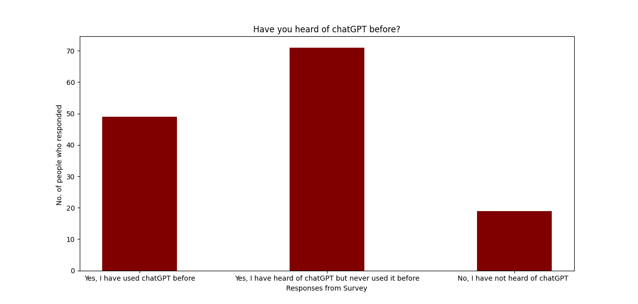

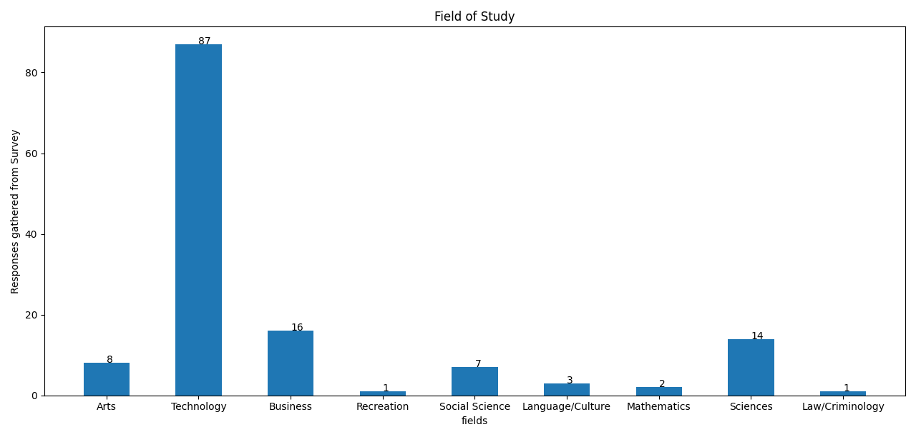**Figure 2:** All respondents field of study

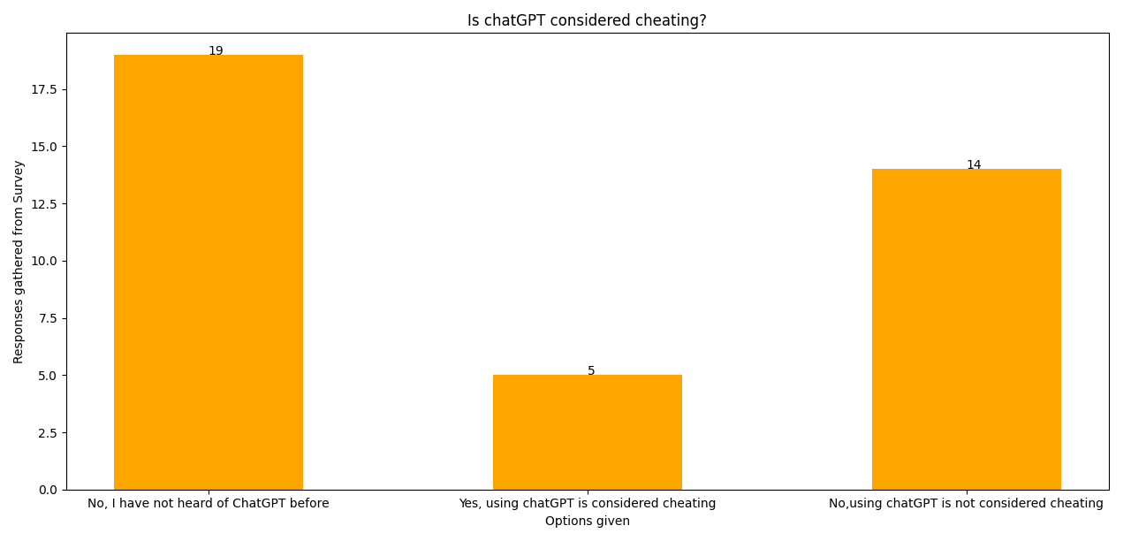

**Figure 3:** For the respondents that have not heard of ChatGPT, whether ChatGPT is considered cheating

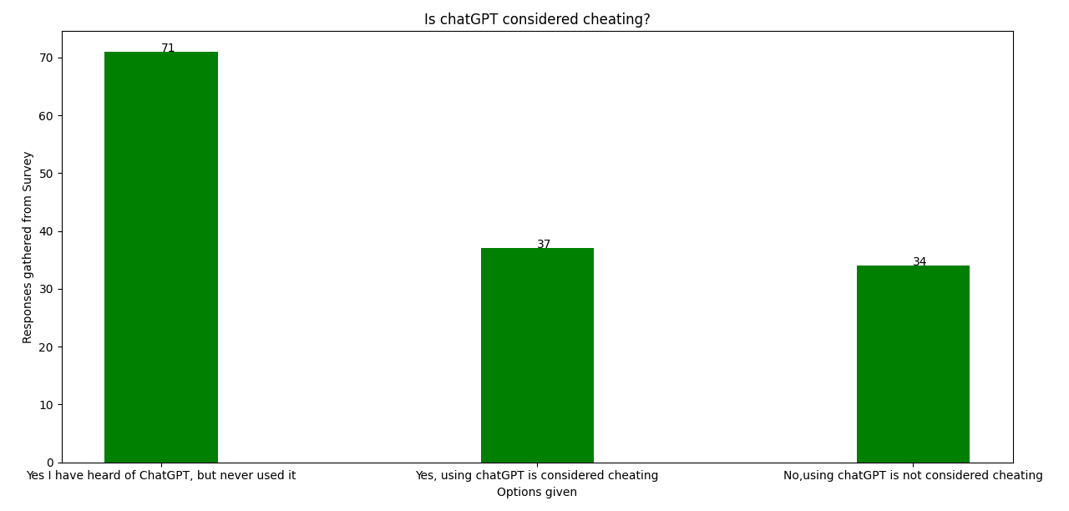

**Figure 4:** For respondents who have heard of ChatGPT but never used it before, whether ChatGPT is considered cheating

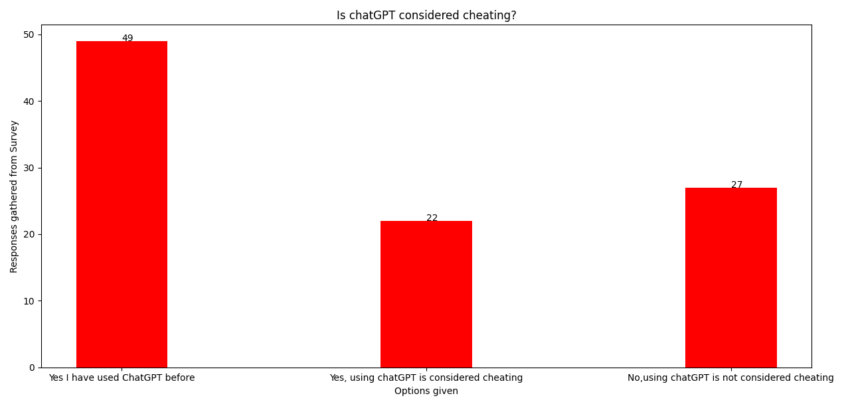

**Figure 5:** For respondents who have used chatGPT, whether ChatGPT is considered cheating

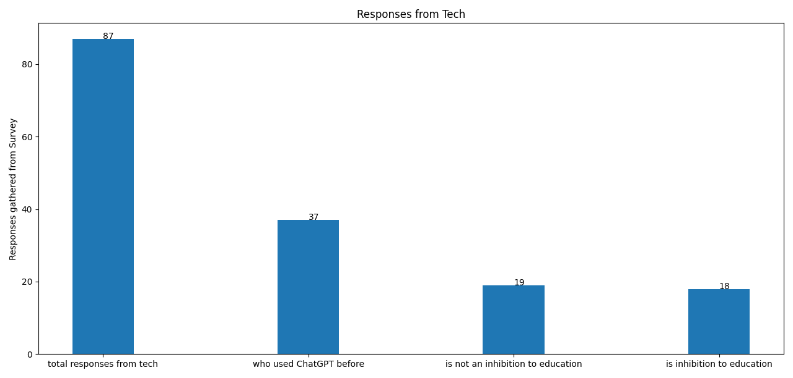

**Figure 6:** From the respondents that come from technology and have used chatGPT, their thought on how ChatGPT will affect academia

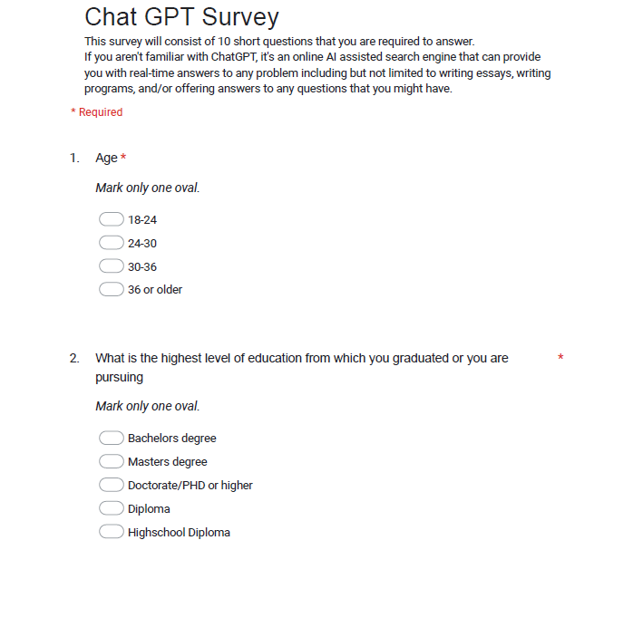

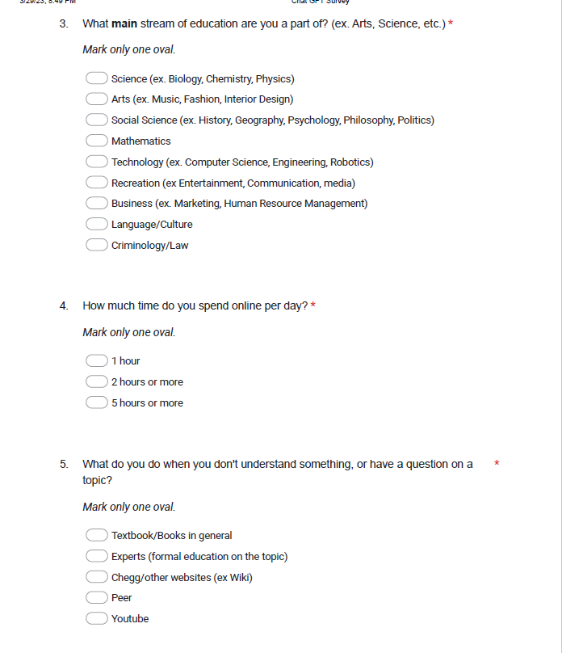

**Figure 7:** Introduction questions for the survey (questions 1-5)

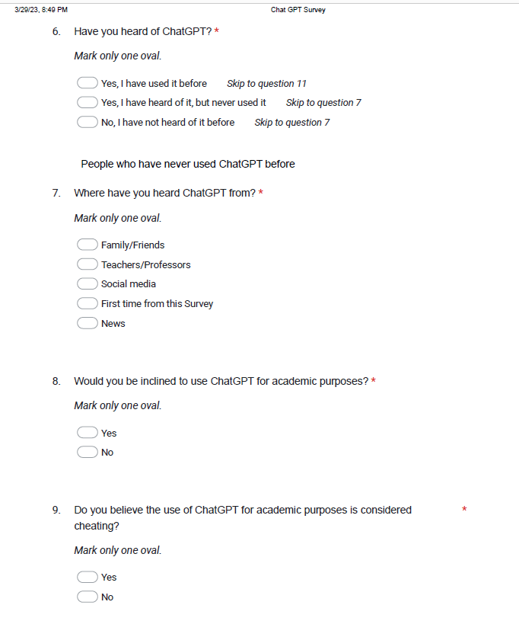

**Figure 8:** Question for respondents who have never used ChatGPT (answered yes, I have heard of it, but never used it or No I have not heard of it before) (questions 7-10)

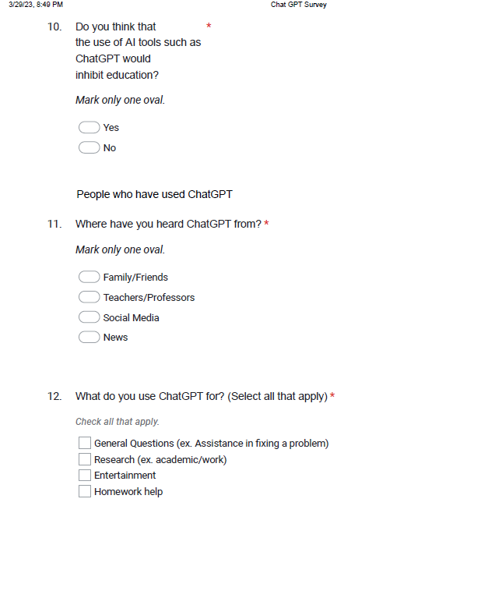

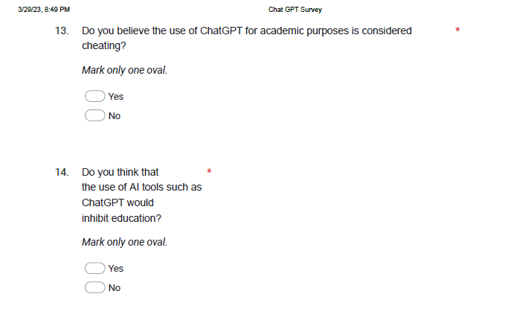

**Figure 9:** Questions for respondents who have used chatGPT (questions 11-14)

**Findings from the data collected**:

Knowledge of ChatGPT has been widespread as a significant majority of respondents knew and or have used ChatGPT. Based on the data collected, 64 respondents believed the usage of ChatGPT is considered cheating, compared to the 75 who do not. From figures 3-6, individuals who have either used chatGPT or have not even heard of it before, have a majority belief in ChatGPT not being considered as cheating. While the individuals who have only heard of ChatGPT while not ever using it holds a majority where the usage is considered cheating. The results from figure 3 contains the most decisive split on opinions among ChatGPT, where a significant majority believed that ChatGPT is not considered cheating. The individuals from this figure are people who have never heard of ChatGPT before the survey. From figure 6, about an even split of people who have used ChatGPT and are from the technology field consider chatGPT to inhibit education, while the other half believes the opposite.

**Benefits and Limitations of ChatGPT**:

The ChatGPT offers people opportunities for the enhancement of learning and teaching experiences for individuals at all levels of education (Kasneci et al., 2023). This model provides a distinctive opportunity to deliver tailored and efficient educational experiences as every person has distinct learning styles and capacities. For example, it assists students to develop problem-solving skills by providing step-by-step solutions and practice problems that are tailored to the student’s level of knowledge. It also has the capacity to transform education and aid in instructional processes. The system helps instructors assess the writing and answers of students, and offers customized feedback and recommends resources that match the individualized learning requirements of the student.

Although there are many benefits to using ChatGPT, there are some limitations users have to beware of. ChatGPT may give outdated information as its training only contains data up to September 2021, which means that it cannot give information about more recent data (Koenders & Könning, 2023). Apart from outdated data, the chatbot can also make calculation and logical errors as this is a chatbot not a mathematical calculator. Another significant limitation of ChatGPT is that it can produce biased or inaccurate information if the data used from training contains any biases. Although it can generate scientifically plausible text, lacks independent scientific reasoning or experimentation abilities and can only produce text based on the information it learned during its training (Ollivier et al., 2023). Finally, it's important to note that when using ChatGPT, it’s always important to review and authenticate the answer before using it.

**Future of ChatGPT:**

The ChatGPT is a vast language model that has potential to revolutionize education in the future as it can imitate human perception and behavior such as learning and problem solving (Pavlik et al., 2023). Therefore, ChatGPT has expressed worries about academic dishonesty and plagiarism, however, there are still numerous ways in which it can be utilized to improve quality of education. It provides automated scoring, quick access to information, and personalized learning (Rehan et al., 2023). The system can evaluate assignments and provide feedback, which means that instructors can save considerable time and focus on more important tasks. Not only that, it can help students to access accurate and recent information and get clarification on a certain topic quickly. In addition, it can serve as a virtual tutor, responding to students’ inquiries and offering feedback on their work. Hence, ChatGPT will hold significant potential for transforming the future of education as it can assist many fields of education.

**Conclusion**:

Chat GPT seems to have a mixed review, although many lean toward saying that using Chat GPT in academic environments is not considered cheating, there is a very fine difference between them and those that do consider it as cheating. Because of this small difference it might be safe to conclude that because of the recent introduction to Chat GPT not many are accustomed to using the tool effectively so that it would boost learning and problem solving.

**References**

Kasneci, E., Sessler, K., Küchemann, S., Bannert, M., Dementieva, D., Fischer, F., Gasser, U., Groh, G., Günnemann, S., Hüllermeier, E., Krusche, S., Kutyniok, G., Michaeli, T., Nerdel, C., Pfeffer, J., Poquet, O., Sailer, M., Schmidt, A., Seidel, T., Stadler, M., Weller, J., Kuhn, J., & Kasneci, G. (2023, March 9). *ChatGPT for good? On opportunities and challenges of large language models for Education*. Science Direct. Retrieved March 27, 2023, from https://www.sciencedirect.com/science/article/pii/S1041608023000195?via%3Dihub

Khan, R. A., Jawaid, M., Khan, A. R., & Sajjad, M. (2023, February 16). *CHATGPT - Reshaping Medical Education and clinical management*. Pakistan Journal of Medical Sciences. Retrieved March 27, 2023, from https://doi.org/10.12669/pjms.39.2.7653

Koenders, L., & Könning, D. (2023, February 2). *What is ChatGPT capable of, and what are its limitations?* Utrecht University. Retrieved March 27, 2023, from https://www.uu.nl/en/education/educational-development-training/knowledge-dossier/what-is-chatgpt-capable-of-and-what-are-its-limitations

Ollivier, M., Pareek, A., Dahmen, J., Kayaalp, M. E., Winkler, P. W., Hirschmann, M. T., & Karlsson, J. (2023, March 9). *A deeper dive into CHATGPT: History, use and future perspectives for Orthopaedic Research*. SpringerLink . Retrieved March 27, 2023, from https://link.springer.com/article/10.1007/s00167-023-07372-5